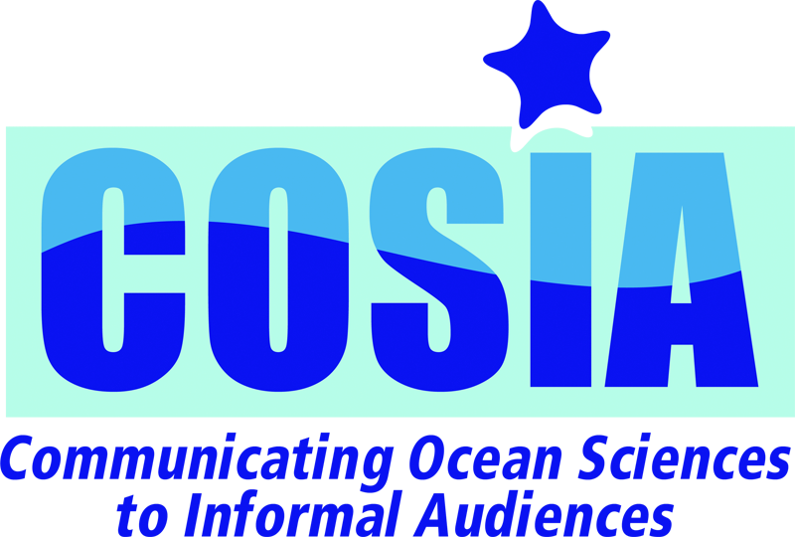
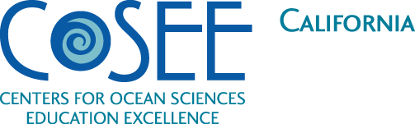
LEARN & TEACH COMMUNICATING OCEAN SCIENCES

COS Instructors' Workshop
August 8-10, 2011

Presented by COSEE — California, and The Lawrence Hall of Science, University of California, Berkeley; Sponsored by the National Science Foundation

The Instructors' Workshop at the University of California Berkeley's Lawrence Hall of Science prepares scientists & science educators interested in teaching one of the Communicating Ocean Sciences (COS) courses, at their institutions.

Communicating Ocean Sciences (COS) are university courses that introduce graduate and undergraduate science students to science pedagogy and learning theory, and helps students to better communicate their knowledge to the public. The courses are designed to be co-taught by an ocean scientist and science educator.

There are two versions of the Communicating Ocean Sciences course:
- Communicating Ocean Sciences to K-12 Audiences (COS-K12) places students in formal K–12 classrooms where they teach a 6-week ocean sciences unit; and
- Communicating Ocean Sciences to Informal Audiences (COSIA) places students in informal learning environments (aquariums, science centers, etc.) where they teach the public about ocean sciences.

Whether you are a scientist at a university or an educator at an informal learning environment, come learn about the course and how you can prepare future ocean scientists to communicate their understanding of and passion for the ocean. Visit the course website for more information and to download the Instructors’ Workshop application form at: http://www.coseeca.net/programs/communicatingoceansciences

CAN’T MAKE IT TO BERKELEY? Don’t worry. We can come to you. If you’d like to host a customized COS Instructor’s Workshop in your region, just let us know.
Additional Info about the Instructors’ Workshop:
During this 2.5-day COS Instructors’ Workshop, we will provide you with:
- Complete syllabus and instructor's guide;
- A full set of curricula for students to take into local classrooms for COS-K12, or COSIA activities that students can use in informal learning environments;
- Correlations of course curriculum to pedagogy and National Science Education Standards;
- Documentation to get the course listed at your site;
- Ongoing technical assistance to ensure successful implementation of the course;
- An introduction to each of the class sessions; and
- Help to customize the syllabus for your local setting and needs.

For more information, please contact:
Catherine Halversen at (510) 642-5008; chalver@berkeley.edu,
Craig Strang cstrang@berkeley.edu or Lynn Tran lynn.tran@berkeley.edu

Quotes from Instructors and Students:

"Co-teaching the class has been fun and gratifying. It is great to have the opportunity to think beyond the typical college lecture format. I have incorporated some of the sessions into my other marine science classes, and my teaching skills have definitely improved, particularly my ability to lead successful class discussions." – Deborah Penry, Faculty Instructor, University of California, Berkeley

“The students say they are learning to refine complex scientific concepts and communicate the important points to the broader public. The benefit they speak of mostly is the confidence building experience of being introduced to the theory and then applying it in a safe environment. The course is like no other course they take in their career.” – COSIA Instructor

“This was a great course that I would recommend all graduate students take at some point during their education. This was a very positive experience and the most applicable and useful class that I have taken to date.” – COSIA Student

“Personally, I felt like I was learning along with the students. Professionally, I am a better teacher in my other classes because of COSIA. Institutionally, our students are much better prepared for their future job search.” – COSIA Instructor

